

STATE OF INDIANA

Request for Proposal 20-042

Addendum #1

INDIANA DEPARTMENT OF ADMINISTRATION

On Behalf Of
Indiana Department of Child Services

Solicitation For:
Design, Development, and Implementation (DDI) of a Comprehensive Child Welfare Information System (CCWIS)

Proposal Due Date: January 31, 2020 @ 3:00pm Eastern Time

David Brandon-Friedman, Senior Account Manager
Indiana Department of Administration
Procurement Division
402 W. Washington St., Room W468
Indianapolis, Indiana 46204
Summary of Changes
Deletions are indicated via strikethrough and additions have been made in red font.

The following edits have been made to the RFP 20-042 Document:

- In Section 1.4.1 - Minimum Requirements

The following addition has been made:

- The Respondent and its subcontractors cannot submit a proposal as a prime contractor or subcontractor for the planned Project Management Office (PMO) procurement and the planned Independent Verification and Validation (IV&V) procurement (if one is issued).

- In Section 1.7 - QUESTION/INQUIRY PROCESS

The following additions have been made to the third and fourth paragraphs:

Following the Round 1 question/inquiry due date, Procurement Division personnel will compile a list of the questions/inquiries submitted by all Respondents. The responses will be posted to the IDOA website according to the RFP timetable established in Section 1.24. The question/inquiry and answer link will become active after responses to all questions have been compiled. Only answers posted on the IDOA website will be considered official and valid by the State. No Respondent shall rely upon, take any action, or make any decision based upon any verbal communication with any State employee. If the Respondent has additional questions solely related to the State’s responses to Round 1 Written Questions, they may submit a Round 2 Written Question. Round 2 Written Questions may be submitted in Attachment G, Q&A Template, via email to rfp@idoa.IN.gov and must be received by the time and date indicated in Section 1.24.

The subject line of the email submissions must clearly state the following:
“RFP 20-042 Round 2 Questions/Inquiries – [INSERT COMPANY NAME]”.

- In Section 1.24 - SUMMARY OF MILESTONES

The following additions have been made:

Key RFP Dates
Activity | Date
Issue of RFP | December 2, 2019
Pre-Proposal Conference (optional) | December 12, 2019, 2:00 PM ET  Conference Center Rooms 1 and 2  Indiana Government Center South
Deadline to Submit Round 1 Written Questions | December 16, 2019  by 3:00 PM Eastern Time
Response to Round 1 Written Questions/RFP Amendments | January 36, 2020
Deadline to Submit Round 2 Written Questions | Janaury 8, 2020  by 3:00 PM Eastern Time
Response to Round 2 Written Questions/RFP Amendments | January 14, 2020
Submission of Letter of Intent to Respond (optional) | January 8, 2020  by 3:00 PM Eastern Time
Submission of Proposals | January 31, 2020  by 3:00 PM Eastern Time
Submission of Reference Check Forms to State | February 10, 2020  by 3:00 PM Eastern Time
The dates for the following activities are target dates only. These activities may be completed earlier or later than the date shown.
Proposal Evaluation | TBD
Proposal Discussions/Clarifications (if necessary) | TBD
Oral Presentations (if necessary) | TBD
Best and Final Offers (if necessary) | TBD
RFP Award Recommendation | March 18, 2020

- In Section 2.4 – TECHNICAL PROPOSAL

The following addition has been made:

The Technical Proposal must be divided into the sections as described below. The Technical Proposal shall be limited to 200 pages, not including resumes, exhibits, or attachments. Every point made in each section must be addressed in the order given. The same outline numbers must be used in the response. RFP language should not be repeated within the response. Where appropriate, supporting documentation may be referenced by a page and paragraph number. However, when this is done, the body of the technical proposal must contain a meaningful summary of the referenced material. The referenced document must be included as an appendix to the technical proposal with referenced sections clearly marked. If there are multiple references or multiple documents, these must be listed and organized for ease of use by the State. The Technical Proposal Template is Attachment F.

The following edits have been made to Attachment C - Scope of Work:

- In Section 7.2 - Training

The following addition has been made to the first paragraph:

The CCWIS training effort is a vital piece to the successful implementation and acceptance of the new system. The Contractor shall provide a high-quality training experience for all end users to ensure a smooth transition from MaGIK to CCWIS. The Contractor will be responsible for creating content, using varying media (live, on-line, recorded, webinars, etc.) that best suits each type of user internal and external to DCS. The Contractor shall deliver end user training up until 90 days after each major rollout phase. The Contractor shall also deliver a comprehensive Train-the-Trainer and Super User course(s) to designated embedded DCS staff from the DCS Unit to enable on-going training resources after the CCWIS implementation and completion of the required Contractor-led end user training.

- In Section 11.1 - Staffing

The following addition has been made to the third paragraph:

The CCWIS Project team will be housed in Indianapolis, Indiana. Contractor staff in Vital Positions (see Section 11.2 below) who are assigned to the project for at least 24 hours in any given week will need to be co-located, on-site full time, and fully dedicated to the project, at the DCS-provided location. The State further reserves the right to request that other staff be made available on-site within one week’s notice unless otherwise approved by the State. There will be space provided at this location for a contractually agreed upon number of additional Contractor staff.

- In Section 13.2.2 – System Performance Standards

The following edit has been made:

Architecture Design Impacts:  - Throughput (Bandwidth)  - Capacity  - Scalability  - Latency | Based on Contractor’s Solution Architect Design and related deliverables | Solution Monitoring | Ranging from $100 to $1000 per business day (depending on defect level, see Section 13.2.1 12.1.1 for appropriate liquidated damages for each defect level) until migrated to UAT environment

The following edits have been made to Attachment D - Cost Proposal Template:

- The tab “Optional Services” has been added:

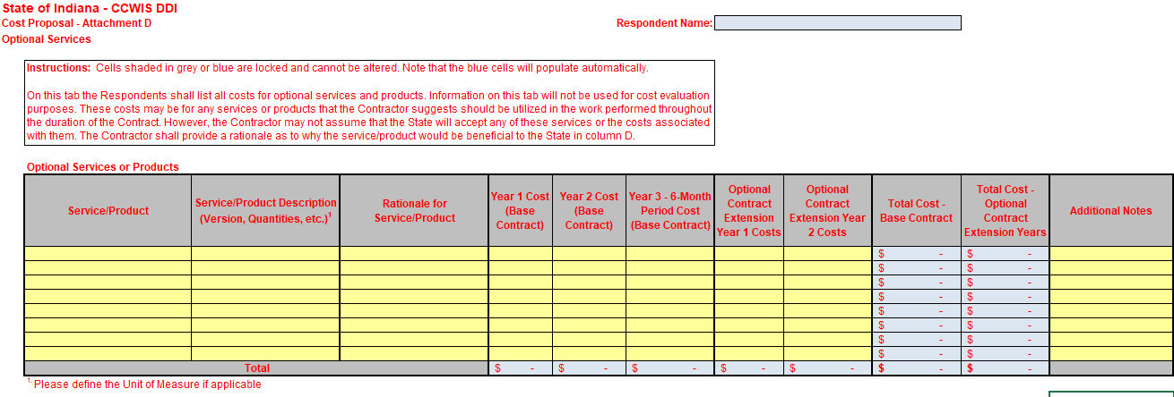

The following edits have been made to Attachment H - Reference Check Form:

- On Page 1

The following edit has been made:

Response Due Date on or before:
02/10/202001/31/2020 at 3:00 PM EST

The following files have been added to Attachment K - Bidders’ Library:

- Exhibit 15 - DCS Human Trafficking Screening and Assessment Tool
- Exhibit 16 - DCS NCMEC Form
- Exhibit 17 - DCS Sample Form Difficult: CAPTA
- Exhibit 18 - DCS Sample Form Difficult: Case Plan
- Exhibit 19 - DCS Sample Form Easy: Notice of Availability
- Exhibit 20 - DCS Sample Form Easy: Notice to Relatives
- Exhibit 21 - DCS Sample Form Medium: Resource Family Preparation Assessment
- Exhibit 22 - DCS Sample Form Medium: Safety Plan
- Exhibit 23 - DCS Sample Reports
- Exhibit 24 - DCS Jira Atlassian Architecture
- Exhibit 25 - DCS Jira Project Add On Purchase Plan 2020

